**PFDE AC Servo Driver PS Series Driver Manual**

PS100/DB100 Series

Revision Hisotry

|  |  |  |
| --- | --- | --- |
| **Version** | **Date** | **Notes** |
| 0.1 | 2/26/2025 | Translated from original quick start document |
|  |  |  |
|  |  |  |
|  |  |  |
|  |  |  |

Contents

Declaration 4

1. Front Panel 5

2. PS100/DB100 Driver Terminal Detail 6

2.1 Main Circuit Terminal Connection Guide 6

2.1.1 Brack Resistor Terminal 7

2.2 CN1 Control Signal Terminal 8

3 The figures below show Input Pulse diagram on Differential or Open-Collector mode: 12

3.1 Digital Input/Output Description 15

3.2 Analog Command Signal Description 15

2.3 CN2 Encoder Signal Terminal 16

2.4 Position Model Configuration 17

4. DO Output Parameter Adjustment 19

5. Input/Output Terminal Parameter Adjustment 20

Internal Position Pt Mode Command Description and Related Parameters 21

5.5 Pre-Operation Checklist 22

Panel Components 24

6.1.2 Button Functions 24

6.2 Main Menu 24

6.3 Parameter Configuration Procedure 25

Steps: 25

6.4 Monitoring Status 26

6.5 Analog Input Zero Calibration 28

6.6 Encoder Operations 29

6.7 Factory Default Parameter Restoration 29

7.1 PA Group Parameters 30

Table 7-1: Drive-Motor Compatibility 30

PA3 - Default Display Configuration 30

Speed Command Configuration (PA22=2) 34

Additional Speed Modes: 34

System Configuration Parameters 36

P3 Group Parameters 39

I/O Configuration Notes 41

Digital Input (DI) Function Definitions 42

Servo Input Terminal Function Definitions 42

Servo Input Terminal Functions (Advanced Control) 43

Servo Control Input Functions 45

Internal Position Command Selection (29, 30, 31 above) 45

Servo Digital Output (DO) Terminal Function Definitions 46

Servo Drive Fault Code Reference 46

8. Servo Alarm Handling Guide 49

9. Encoder Cable Wires Color 54

Declaration

**Before using this servo motor and driver, please read the following terms and conditions:**

1. The original manual was provided by the manufacturer in a non-English language. Our team has translated it into English for convenience. However, we have **not** tested the functionality of the motor and driver as described in the manual, so we cannot verify full compatibility or performance.
2. This servo motor and driver require an external power source, either low-voltage DC or AC (220V, 50/60Hz). **Users must follow proper safety precautions and assume all associated risks.**
3. Improper use of this servo motor and driver may cause equipment damage or disrupt your workflow. **The user assumes full responsibility for any resulting risks or losses.**
4. Front Panel

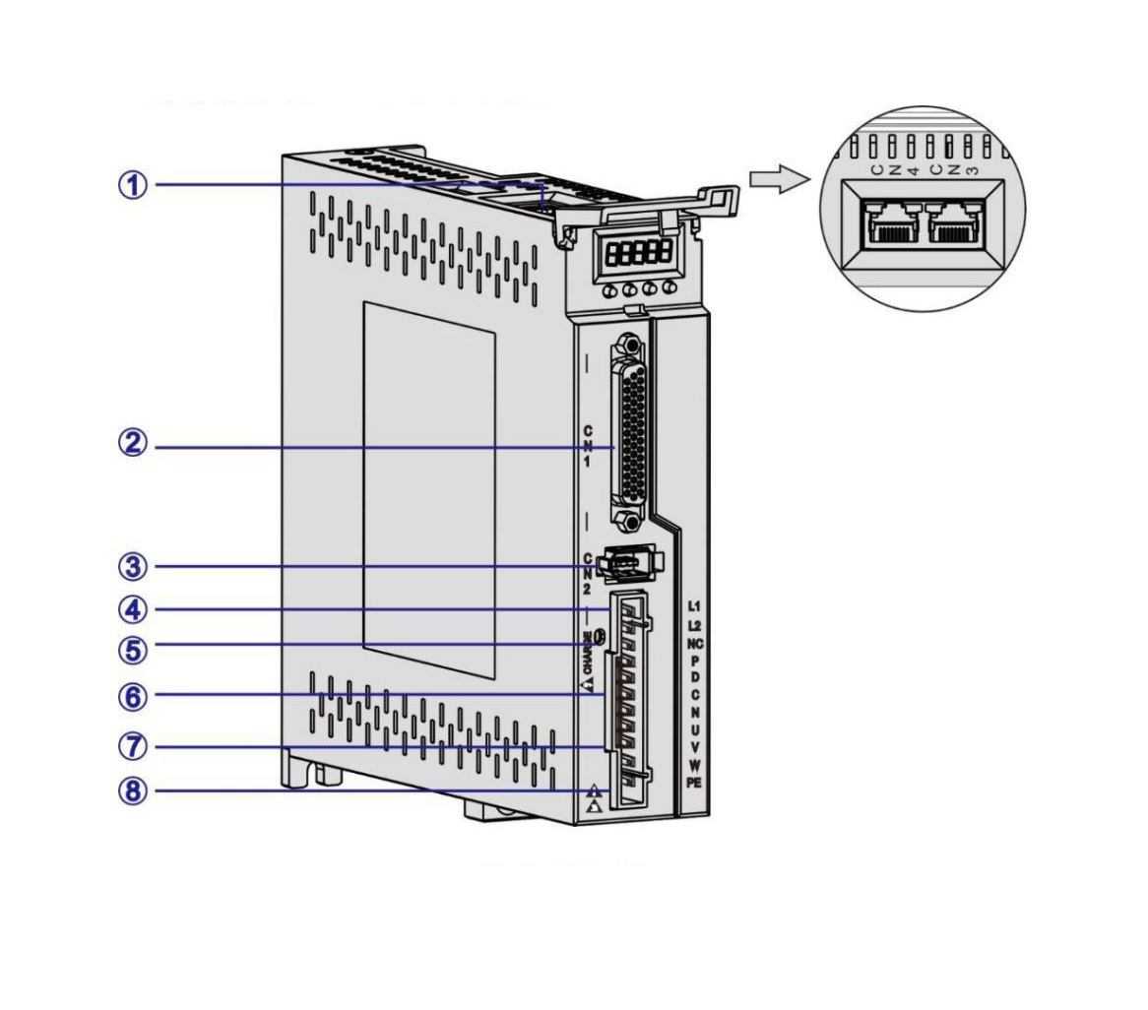

Figure 1

|  |  |  |
| --- | --- | --- |
| Index | Terminal | Function |
| 1 | CN3, CN4 | RS485 Communication |
| 2 | CN1 | Input, Output Control Signal |
| 3 | CN2 | Encoder. Connect with Motor Encoder |
| 4 | L1, L2 | AC Power Input |
| 5 | CHARGE | Power Indicator Light. |
| 6 | P,D,C,N | Braking resistor terminal block |
|  |  |  |
| 7 | UVW | Servo Motor wire connector. Connect to Motor’s UVW wire |
| 8 | PE | GRD terminal. Share terminal with servo motor and PSU |

1. PS100/DB100 Driver Terminal Detail

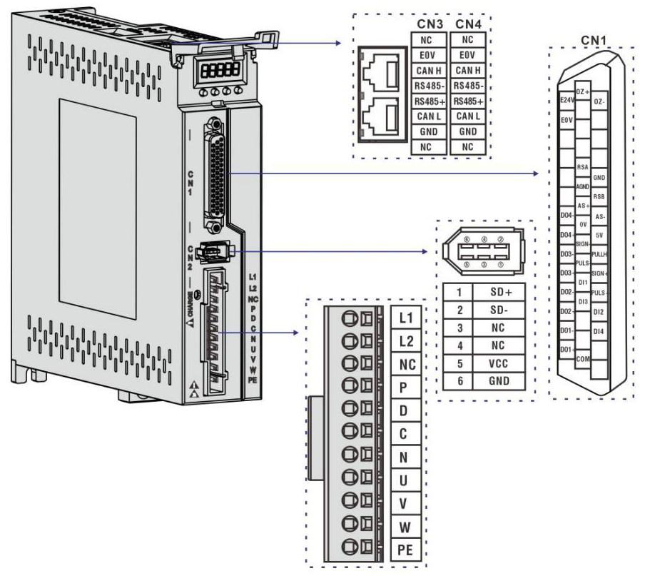

Figure 2

## 2.1 Main Circuit Terminal Connection Guide

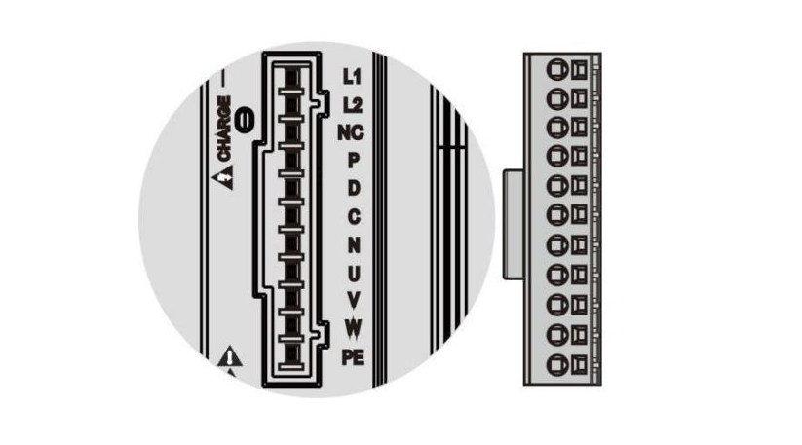

Figure 3

|  |  |  |
| --- | --- | --- |
| Terminal Name | Sign | Function |
| Power Input | L1, L2 | Single-phase 220V AC 50/60HZ |
| NC | N/A |
| Braking resistor terminal block | P, D | When using the internal braking resistor, short-circuit P and D. (Default). See Figure 4 – A below. |
| P, C | When using an external braking resistor, disconnect the short circuit between P and D, then connect the external braking resistor wires between P and C. Do not connect P and N. See Figure 4 – B below. |
| Motor Connector Terminal | U, V, W | Connect to the servo motor's U, V, and W phases. |
| PE | Connect the drive's ground terminal to the power supply and motor ground terminals. |

## 2.1.1 Brack Resistor Terminal

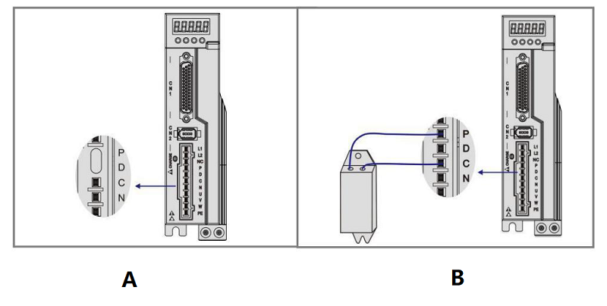

Figure 4

**Caution:**

1. Do not connect Brack Resistor on the main wire terminal Positive (P) and Neutral (N), or causing short circuits and fires
2. Do not use resistor that less than 25 Ω, or causing the driver to alarm or damage the driver.
3. Install resistor on a non-flammable metal material

## 2.2 CN1 Control Signal Terminal

CN1 control signal terminal provides the necessary signals for connection with the upper-level controller, using a DB44 socket. The signals include:

* 4 programmable inputs
* 4 programmable outputs
* Analog command input
* Command pulse input

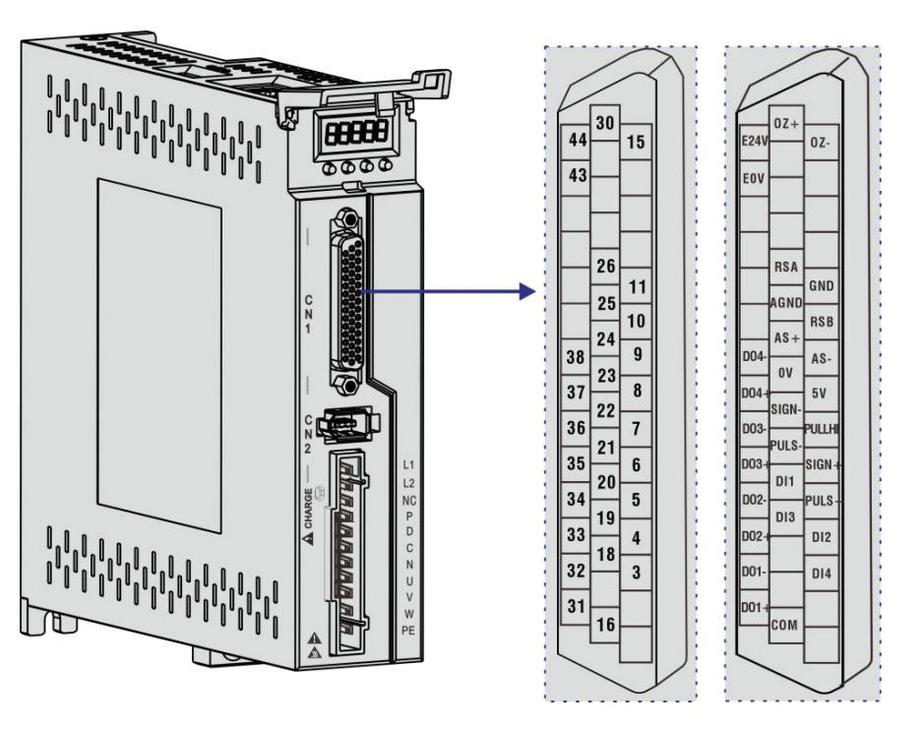

Figure 5

The Figure 6 below shows the DB44 terminal pinout:

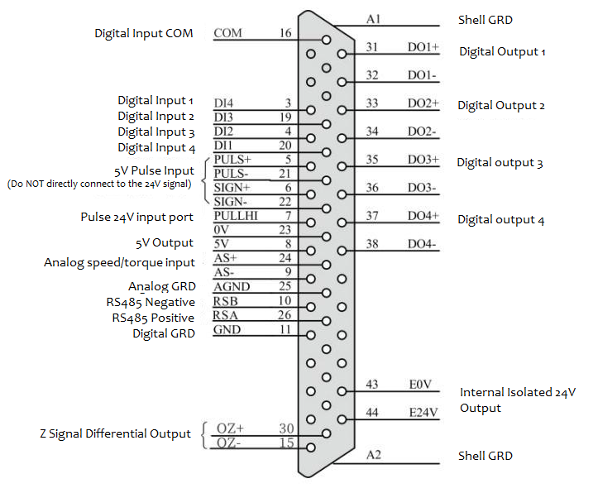

Figure 6

2.2.1 Position Pulse Command Description

|  |  |  |  |  |
| --- | --- | --- | --- | --- |
| Signal Name | | | Pin # | Feature |
| Position Pulse Command | PLUS + | 5 | | High-speed optically isolated input, parameter PA14 setting working modes:   * Pulse + Direction * CCW/CW Pulse * A, B two-phase quadrature pulse input * Internal position control input   External 24V power supply input interface for command pulses  Internal digital signal ground |
| PLUS - | 21 | |
| SIGN + | 6 | |
| SIGN - | 22 | |
| PULLHI | 7 | | External 24V Input for command pulses |
| GRD | 11 | | Internal signal ground |

The host device command pulse circuit can be selected from either differential driver output or open-collector input. The maximum input frequency and minimum pulse width are shown in the table below.

|  |  |  |
| --- | --- | --- |
| Pulse Type | Max Input Frequency (PPS) | Min Pulse Width (us) |
| Differential | 500K | 1 |
| Open-Collector | 200K | 2.5 |

**Caution**:

1. If the host device output pulse width smaller minimal Pulse Width, causing controller receiver pulse error.
2. Plus + and Plus -, Sign + and Sign – only support 5V or less DC voltage. Any voltage above 5V will damage controller.

# 3 The figures below show Input Pulse diagram on Differential or Open-Collector mode:

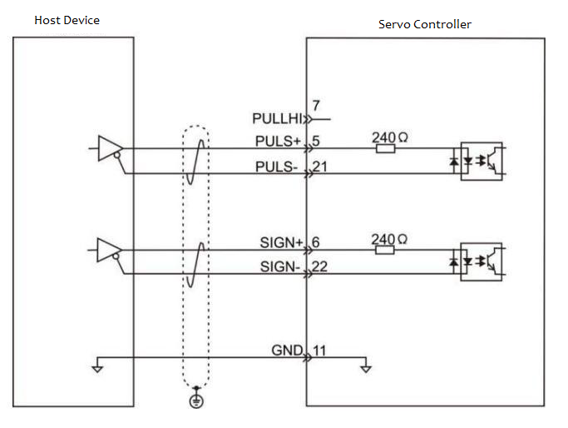

Figure 7 Differential

1. When using controller internal 24V
   1. Common Anode Connection

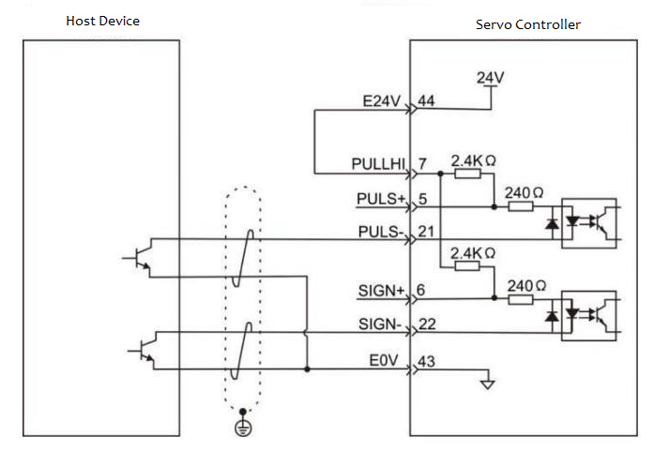

Figure 8 Open-Collector

1. When using external 24V DC
   1. Use Internal Resistor. Common Anode Connection (Suggested)

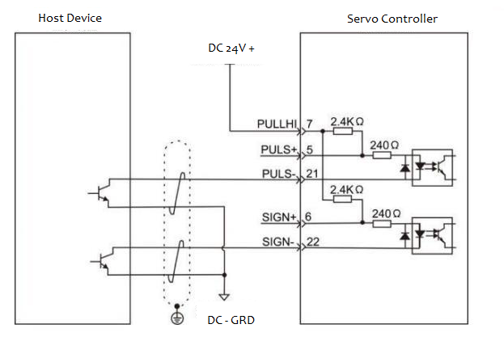

Figure 9

* 1. Use external resistor

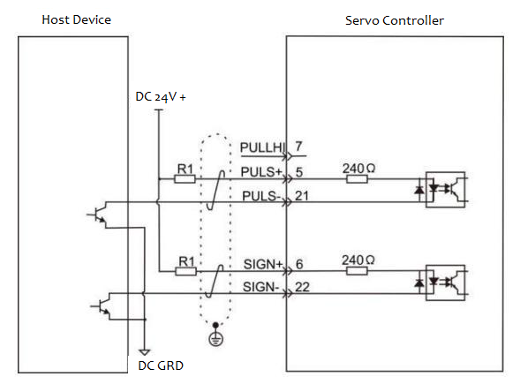

Figure 10

Sample of External Resistors:

|  |  |  |
| --- | --- | --- |
| VCC Voltage | R1 ohm | R1 Power |
| 24V | 2.4K | 0.5W |
| 12V | 1.5K | 0.5W |

### Digital Input/Output Description

|  |  |  |  |  |
| --- | --- | --- | --- | --- |
| Signal | | Pin | Default | Description |
| Digital Input | DI 1 | 20 | Servo Enable | Optically isolated input with programmable functions, defined by parameter group P3 (P3-0 to P3-17).  **Caution:** The COM port is a common-anode interface with an input voltage of 12V-24V.  In position mode and non-position mode:   * Connect 24V to pin 7. * Connect DI 5 to pin 21. * Connect DI 6 to pin 22. |
| DI 2 | 4 | Alarm Clear |
| DI 3 | 19 | Forward drive disabled |
| DI 4 | 3 | Backward drive disabled |
| PULS- | 21 |  |
| SIGN- | 22 |  |
| PULS+ | 5 |  |
| SIGN+ | 6 |  |
| PULLHI | 7 |  |
| COM | 16 | Digital Signal Common |
| Digital Output | DO 1+ | 31 | Z Signal output | Optically isolated input with programmable functions, defined by parameter group P3 (P3-20 to P3-23). |
| DO 1- | 32 |
| DO 2+ | 33 | Alarm output |
| DO 2- | 34 |
| DO 3+ | 35 | Position Finished |
| DO 3- | 36 |
| DO 4+ | 37 | Electromagnetic brake |
| DO 4- | 38 |
| DO 5+/RSA | 26 | RS485 + |
| DO 5-/RSB | 10 | RS485 - |
| Internal DC output | 0V | 23 | Internal 0V | Internal 5V output, max current 200mA |
| 5V | 8 | Internal 5V |
| Internal Isolated DC output | E0V | 43 | Internal 0V | Internal 24V output, 20V~28V, max current 100mA |
| E24V | 44 | Internal 24V |

### Analog Command Signal Description

|  |  |  |  |
| --- | --- | --- | --- |
| Signal | | Pin | Function |
| Analog Command | AS+, AT+ | 24 | Speed/Torque Analog signal input, Range: -10V~+10V |
| AS-, AT- | 9 |
| AGND | 25 |

## 2.3 CN2 Encoder Signal Terminal

Encoder signal terminal use 6 Pin socket. See figure below:

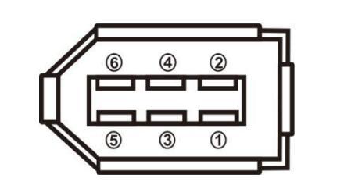

Figure 11

|  |  |  |  |
| --- | --- | --- | --- |
|  | | Pin |  |
| Signal Power | 5V | 5 | Encoder 5V DC. Provided by controller. |
| 0V | 6 |
| Communication Pins | SD+ | 1 | Encoder communication + |
| SD- | 2 | Encoder communication - |
| N/A | NC | 3 | Reserved |
| N/A | NC | 4 | Reserved |
| GRD | Metal Shell | | Encoder wire Shielding Layer |

## Position Model Configuration

According to the command mode and operating characteristics of the servo driver, it can be divided into three operating modes: position control mode, speed control mode, and torque control mode.

* **Position Control Mode:** This mode typically determines the movement position through the number of pulses, while the externally input pulse frequency determines the rotational speed. Since position control mode allows strict control over position and speed, it is the most commonly used mode in servo systems, mainly used in placement machines, chip mounters, engraving and milling machines, and CNC machine tools.
* **Speed Control Mode:** In this mode, speed is controlled through analog input, digital input, or communication command input. It is mainly applied in scenarios requiring constant speed, such as lathe applications. In lathes, the upper computer generally adopts position control mode, while the servo driver adopts speed control mode.
* **Torque Control Mode:** Torque is controlled through analog input, digital input, or communication command input. This mode is mainly used in applications requiring strict material tension control, such as wire drawing equipment or optical fiber pulling devices. In such cases, the torque setting must be adjusted according to the change in winding radius to ensure that the material’s tension remains unchanged during winding.

Position mode is a common working mode of the servo driver. The main usage steps are as follows:

1. Ensure that the power supply for the servo main circuit and control circuit is correctly connected, as well as the motor power cable and encoder cable. After powering on, the display on the servo driver should show , indicating that the servo power and encoder connections are correct.
2. Perform a JOG test run using the buttons to confirm whether the motor operates normally.
3. Refer to Figure 5.2 to correctly connect the pulse direction input and pulse command input at the CN1 terminal, as well as the necessary DI/DO signals, such as servo enable, alarm reset, and positioning completion signals.
4. Configure position mode-related settings. Set the required DI/DO signals according to the actual situation.
5. Enable the servo and send a position command from the upper controller to control the servo motor's rotation. First, rotate the motor at a low speed to confirm whether the rotation direction and electronic gear ratio are correct, and then proceed with gain adjustments.
   1. Position Control Mode Wiring Diagram:

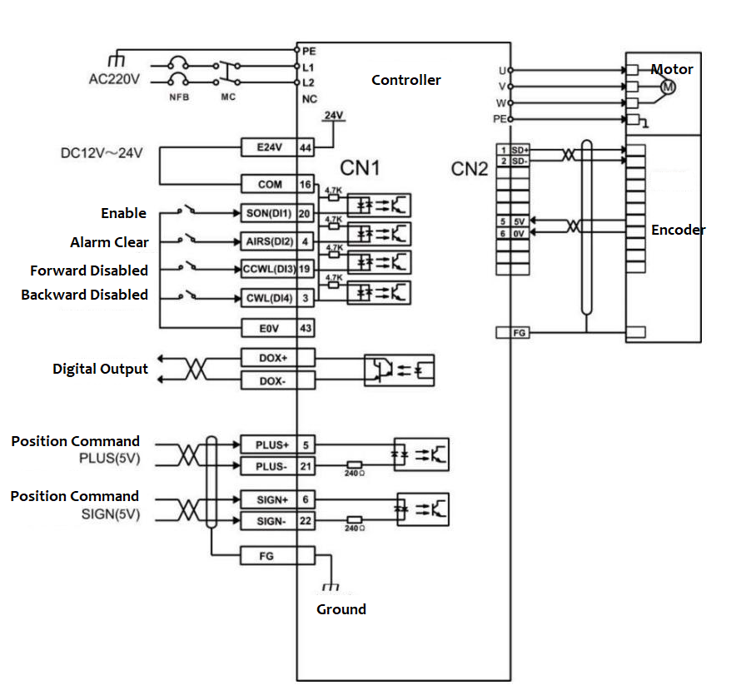

Figure 12

* 1. The table below list the parameters that related with the Position Operation Model:

|  |  |  |  |
| --- | --- | --- | --- |
| Parameter | Description | Value Range | Factory Default |
| PA4 | **Control Mode Selection** | 0 | 0 |
| PA9 | **Position Proportional Gain** | 1-1000 | 80 |
| PA19 | **Position Command Smoothing Filter** | 0-1000x-0.1ms | 100 |
| PA100 | **Command Filter Selection** | 0-1 | 0 |

|  |  |  |  |
| --- | --- | --- | --- |
| Parameter | Description | Value Range | Factory Default |
| PA11 | Number of command pulses per motor revolution | 0-30000 | 10000 |
| PA12 | Numerator of the position command pulse electronic gear (first term) | 1-32767 | 0 |
| PA13 | Denominator of the position command pulse electronic gear | 1-32767 | 10000 |
| PA14 | Position command pulse input method | 0-3 | 0 |
| PA15 | Invert the direction of the position command pulse | 0-1 | 0 |
| PA59 | Valid edge of the command pulse | 0-1 | 0 |
| PA77 | Numerator of the position command pulse electronic gear ratio (second term) | 1-32767 | 0 |
| PA78 | Numerator of the position command pulse electronic gear ratio (third term) | 1-32767 | 0 |
| PA79 | Numerator of the position command pulse electronic gear ratio (fourth term) | 1-32767 | 0 |
| PA80 | Effective level of the command direction signal | 0-1 | 0 |
| PA81 | Filter for the command pulse PULS signal | 0-15 | 4 |
| PA82 | Filter for the command pulse SIGN signal | 0-15 | 4 |

# DO Output Parameter Adjustment

| Parameter | Parameter Description | Value Range | Factory Default |
| --- | --- | --- | --- |
| PA16 | Positioning completion range | 0-3000 pulses | 130 |
| PA17 | Position deviation detection range | 0-30000×100 pulses | 6000 |
| PA18 | Position deviation error disable | 0-1 | 0 |
| PA83 | CWL, CCWL direction inhibit mode | 0-1 | 0 |
| PA84 | Positioning completion backlash | 0-32767 | 65 |
| PA85 | Positioning proximity range | 0-32767 | 6500 |
| PA86 | Positioning proximity backlash | 0-32767 | 650 |

# Input/Output Terminal Parameter Adjustment

| **Parameter** | **Parameter Description** | **Parameter Value** | **Factory Default** |
| --- | --- | --- | --- |
| PA55 | Input terminal active level control word | 0000-1111 (binary) | 0000 |
| PA57 | Output terminal active level control word | 0000-1111 (binary) | 0000 |
| PA58 | I/O input terminal debounce time constant | 1-20 ms | 2 |
| P3-0 | Digital input DI1 function | 0-99 | 1 |
| P3-1 | Digital input DI2 function | 0-99 | 2 |
| P3-2 | Digital input DI3 function | 0-99 | 3 |
| P3-3 | Digital input DI4 function | 0-99 | 4 |
| P3-15 | Digital input DI forced active 1 | 00000000-11111111 (binary) | 00000000 |
| P3-16 | Digital input DI forced active 2 | 00000000-11111111 (binary) | 00000000 |
| P3-17 | Digital input DI forced active 3 | 00000000-11111111 (binary) | 00000000 |
| P3-20 | Digital output DO1 function | 0-99 | 18 |
| P3-21 | Digital output DO2 function | 0-99 | 3 |
| P3-22 | Digital output DO3 function | 0-99 | 5 |
| P3-23 | Digital output DO4 function | 0-99 | 8 |

### Internal Position Pt Mode Command Description and Related Parameters

In Position Pt mode, the position command source uses built-in registers (P4-2, P4-3) to (P4-23, P4-24) with 8 preset position commands. External I/O (CN1, POS0-POS2, and CTRG) can select one of the eight groups as the position command:

| **Position Command** | **POS2** | **POS1** | **POS0** | **CTRG** | **Corresponding Parameters** | **Description** | **Speed Register** |
| --- | --- | --- | --- | --- | --- | --- | --- |
| P1 | 0 | 0 | 0 | ↑ | P4-2 | Revolutions (+/-30000) | P4-4 (V1) |
|  |  |  |  |  | P4-3 | Pulses (+/-max count) |  |
| P2 | 0 | 0 | ↑ | ↑ | P4-5 | Revolutions (+/-30000) | P4-7 (V2) |
|  |  |  |  |  | P4-6 | Pulses (+/-max count) |  |
| P3 | 0 | 1 | ↑ | ↑ | P4-8 | Revolutions (+/-30000) | P4-10 (V3) |
|  |  |  |  |  | P4-9 | Pulses (+/-max count) |  |
| P4 | 0 | 1 | ↑ | ↑ | P4-11 | Revolutions (+/-30000) | P4-13 (V4) |
|  |  |  |  |  | P4-12 | Pulses (+/-max count) |  |
| P5 | 1 | 0 | ↑ | ↑ | P4-14 | Revolutions (+/-30000) | P4-16 (V5) |
|  |  |  |  |  | P4-15 | Pulses (+/-max count) |  |
| P6 | 1 | 0 | ↑ | ↑ | P4-17 | Revolutions (+/-30000) | P4-19 (V6) |
|  |  |  |  |  | P4-18 | Pulses (+/-max count) |  |
| P7 | 1 | 1 | ↑ | ↑ | P4-20 | Revolutions (+/-30000) | P4-22 (V7) |
|  |  |  |  |  | P4-21 | Pulses (+/-max count) |  |
| P8 | 1 | 1 | ↑ | ↑ | P4-23 | Revolutions (+/-30000) | P4-25 (V8) |
|  |  |  |  |  | P4-24 | Pulses (+/-max count) |  |

### 5.5 Pre-Operation Checklist

First, disconnect all loads connected to the servo motor, including couplings and related accessories on the motor shaft. Ensure the servo motor operates correctly under no-load conditions before reconnecting the load to avoid potential hazards.

#### Pre-Operation Inspection:

1. **Visual Check**:
   * Ensure the servo drive shows no visible physical damage.
2. **Wiring Insulation**:
   * Verify all terminal connections are properly insulated.
3. **Foreign Objects**:
   * Confirm no conductive materials (e.g., screws, metal fragments) or flammable objects are inside the drive.
   * Check for no conductive debris near wiring ports.
4. **Placement**:
   * Ensure the servo drive or external braking resistor is not placed on flammable surfaces.
5. **Wiring Integrity**:
   * Validate all wiring is complete and correctly connected.

#### Electrical Safety Checks:

* **Power and Grounding**:
  + Verify correct wiring of main power, auxiliary power, and grounding terminals.
  + Confirm proper connections for control signal cables, limit switches, and protection signals.
* **Initial State**:
  1. Set the enable switch to **OFF**.
  2. Ensure the power circuit and emergency stop/alarm circuit remain uninterrupted.
  3. Confirm the servo drive’s input voltage reference is correct.

#### Power-On Test (No Command Signal):

1. **Motor Behavior**:
   * Check for smooth rotation without vibration or excessive noise.
2. **Parameter Settings**:
   * Validate all parameters are correctly configured. Avoid extreme settings that may cause unintended motions due to mechanical characteristics.
3. **Indicators**:
   * Monitor the bus voltage LED and digital display for abnormalities.

### Panel Components

The panel consists of **5 LED digital displays** and **4 buttons (▲, ▼, ◄, SET)**, used to display system statuses and configure parameters. Operations follow a hierarchical menu structure, navigated layer by layer from the main menu.

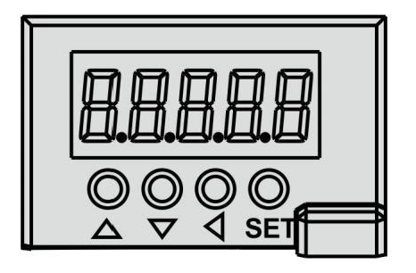

Figure 13

### 6.1.2 Button Functions

| **Symbol** | **Name** | **Functionality** |
| --- | --- | --- |
| ▲ | Increment | Increases sequence numbers or values; long press enables rapid repeat. |
| ▼ | Decrement | Decreases sequence numbers or values; long press enables rapid repeat. |
| ◄ | Exit | Exits menus or cancels operations. |
| SET | Enter/Confirm | Confirms selections or operations. |

# 6.2 Main Menu

The first layer is the main menu, offering 8 operation modes. Use the **▲/▼** buttons to navigate between modes, press **SET** to enter the second layer for specific operations, and press **◄** to return to the main menu from the second layer.

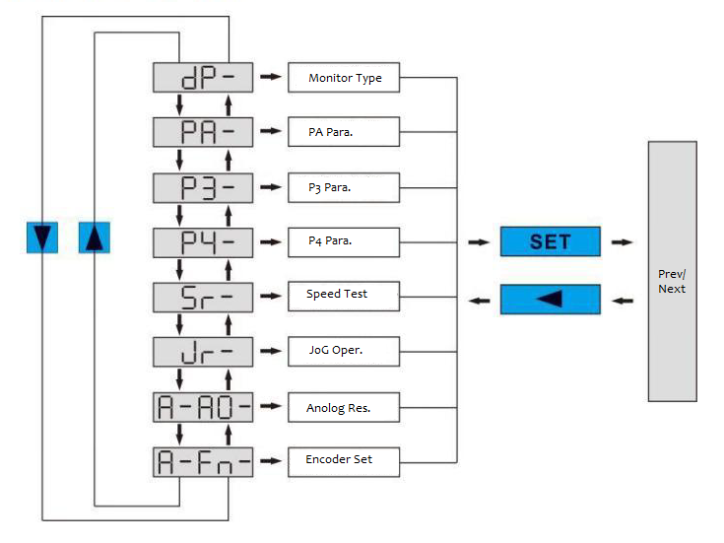

Figure 14

## 6.3 Parameter Configuration Procedure

Parameters are identified by a **segment + number** format, where the hundreds digit represents the segment and the tens/units digits represent the parameter number. For example, parameter **PA53** has segment "PA" and number "53", displayed as "PA-53" on the screen.

### Steps:

1. **Enter Parameter Mode**:
   * From the main menu, select "P-" (Parameter Setup) and press **SET**.
2. **Select Parameter Segment**:
   * Use **▲/▼** to choose the segment (e.g., PA, PB), then press **SET**.
3. **Select Parameter Number**:
   * Use **▲/▼** to pick the parameter number (e.g., 53), then press **SET** to display its value.
4. **Modify Values**:
   * Adjust with **▲/▼**:
     + Single press: Increment/decrement by 1.
     + Long press: Continuous rapid adjustment.
   * Press **SET** to confirm. The rightmost LED decimal point will blink twice, indicating the change is applied.
     + Note: Some parameters require a power cycle to take effect.

### 6.4 Monitoring Status

The first layer provides 8 operation modes. Use the **▲/▼** buttons to navigate between modes, press **SET** to enter the selected mode's second layer, and press **◄** to return to the first layer.

#### Steps to Monitor Status:

1. **Enter Monitoring Mode**:
   * From the first layer, select **"dp--"** and press **SET**.
2. **Select Display Mode**:
   * Use **▲/▼** to cycle through 23 available status display options.
3. **View Status**:
   * Press **SET** to confirm and enter the selected display mode.

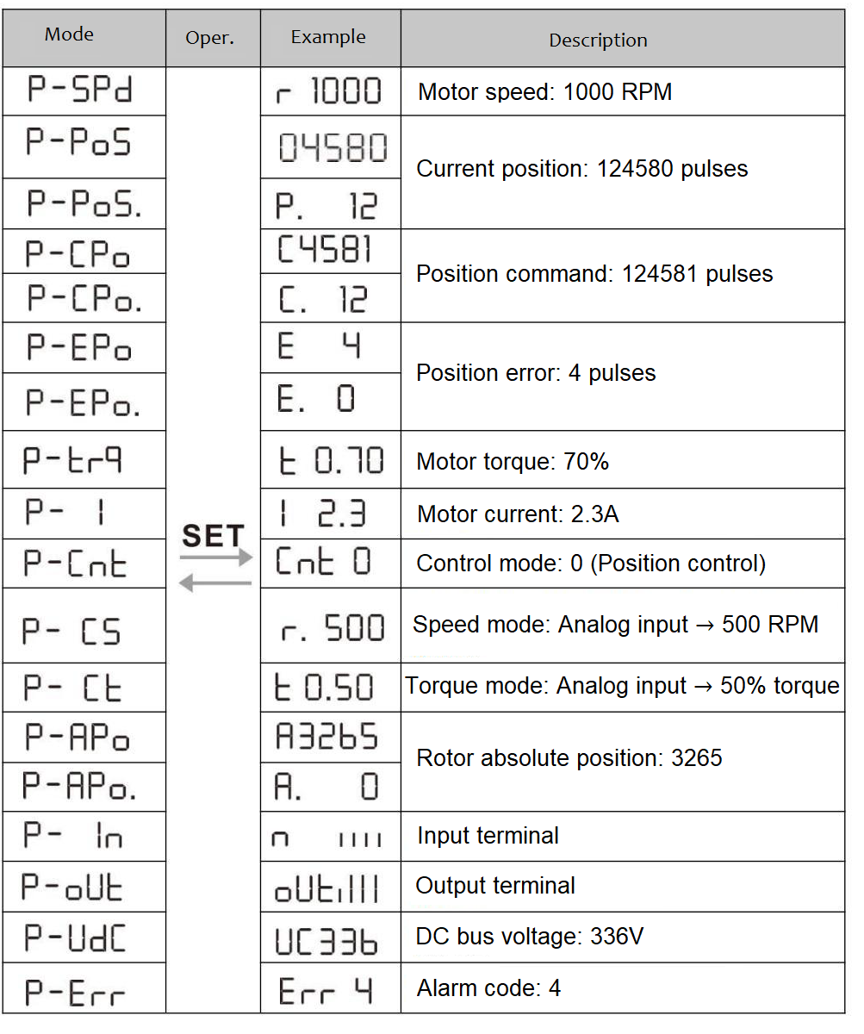

Figure 15

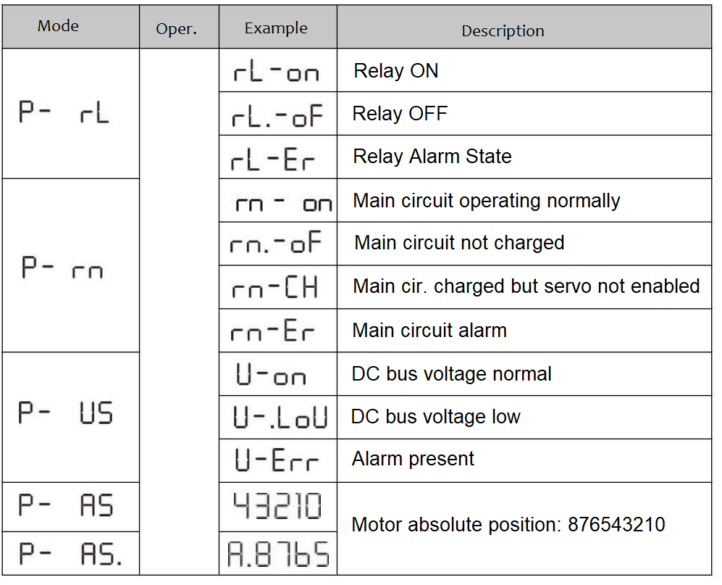

Figure 16

### 6.5 Analog Input Zero Calibration

This function automatically detects analog input offset and writes the value to parameter PA39 (or PA45). The offset value is saved to EEPROM automatically - no manual parameter write operation is required.

#### Procedure:

1. Select **"A-AO"** (Analog Zero) and press **SET**.
2. Choose calibration mode:
   * **"A-SPd"**: Speed analog input zero calibration
   * **"A-Trq"**: Torque analog input zero calibration
3. Press and hold **SET** for 3+ seconds until "done" appears.
4. Press **◄** to return to menu.

### 6.6 Encoder Operations

#### Functions:

1. **"F-res"** (Encoder Reset):
   * Clears multi-turn data (sets to zero).
   * Combine with parameter **P3-36** to clear single-turn data for homing.
2. **"F-clr"** (Alarm Clear):
   * Resolves Alarm 53 (caused by encoder battery failure).

#### Execution:

* Select operation and hold **SET** for 3+ seconds until "done" appears.
* Press **◄** to exit.

### 6.7 Factory Default Parameter Restoration

Use this function when:

* Parameters become corrupted, causing system malfunction.

#### Restoration Procedure:

1. **System Preparation**
   * Ensure motor-driver connection is secure
   * Power cycle the drive to auto-detect motor parameters
2. **Password Authentication**
   * Navigate to: Main Menu → "PA-" → SET
   * Set PA0 = 385 (default password) → Confirm with SET
3. **Execute Factory Reset**
   * Within "PA-" menu:  
     a. Set PA1 = DEF-  
     b. Long-press SET for 5 seconds until LED blinks  
     c. Power cycle to activate

Note: This overwrites ALL user-modified parameters with factory defaults.

Function Parameters

# 7.1 PA Group Parameters

| **ID** | **Parameter** | **Functionality** | **Range** | **Default** |
| --- | --- | --- | --- | --- |
| 0 | Password | 1. User password: 315 | 0-9999 | 315 |
|  |  | 2. Model code: 385 (for factory reset) |  |  |
| 1 | Model Code | Read-only. Drive auto-detects motor model. | 40-80 | See Table 7-1 |
| 2 | Firmware Version | Displays software version (read-only) | - | - |

## Table 7-1: Drive-Motor Compatibility

| **Drive Model** | **P100S-40** | **P100S-75** |
| --- | --- | --- |
| Compatible Motors | 40-00130 | 80-01330 |
|  | 40-00330 | 80-02430 |
|  | 60-00630 | 80-03230 |
|  | 60-01330 | -- |
|  | 60-01930 | -- |
|  | 80-01330 | -- |

### PA3 - Default Display Configuration

| **ID** | **Parameter** | **Functionality** | **Range** | **Default** |
| --- | --- | --- | --- | --- |
| 3 | Startup Display Mode | 0 Motor speed RPM  1 Current position (low 5 digits) Pulses (LSW)  2 Current position (high 5 digits) Pulses (MSW)  3 Position command (low 5 digits) Accumulated pulses (LSW)  4 Position command (high 5 digits) Accumulated pulses (MSW)  5 Position error (low 5 digits) Pulses (LSW)  6 Position error (high 5 digits) Pulses (MSW)  7 Motor torque % of rated  8 Motor current Amperes  9 Control mode 0:Pos,1:Spd,2:Trq  10 Temperature °C  11 Speed command RPM  12 Torque command % of rated  13 Single-turn position (low 5 dig) Pulses (LSW)  14 Single-turn position (high 5 dig) Pulses (MSW)  15 Input terminal states Binary (e.g., 1011)  16 Output terminal states Binary (e.g., 0110)  17 Encoder input signals A/B/Z phase status  18 DC bus voltage Volts  19 Alarm code (e.g., E.21)  20 Logic IC version Hexadecimal  21 Relay engagement status ON/OFF  22 Operation state 0:Stop,1:Run,2:Alarm  23 External voltage status Volts  24 Absolute position (low 5 digits) Pulses (LSW)  25 Absolute position (high 5 digits) Pulses (MSW) | 0-25 | 0 (Motor Speed) |

| **ID** | **Parameter** | **Functionality** | **Range** | **Default** |
| --- | --- | --- | --- | --- |
| 4 | **Control Mode** | Sets operational mode: • 0: Position control • 1: Speed control • 2: Torque control • 3: Position-speed hybrid • 4: Position-torque hybrid • 5: Speed-torque hybrid • 6: Encoder zeroing mode | 0-6 | 0 |
| 5 | **Speed Prop. Gain (Kp)** | • Speed loop proportional gain • Higher values increase stiffness but may cause oscillation • Scale with load inertia (↑ inertia → ↑ gain) | 5-2000 Hz | 150 |
| 6 | **Speed Int. Time (Ti)** | • Speed loop integral time • Lower values = faster correction ↑ stiffness • Excessively low values cause overshoot | 1-1000 ms | 75 |
| 7 | **Torque Filter** | • Suppresses torque-induced resonance • Lower % = ↓ cutoff freq. (smoother but slower) • Higher % = ↑ response (risk of vibration) | 20-500% | 100 |
| 8 | **Speed Detect Filter** | • Filters speed feedback noise • Lower % = quieter operation • Higher % = faster response | 20-500% | 100 |

| **ID** | **Parameter** | **Functionality** | **Range** | **Default** |
| --- | --- | --- | --- | --- |
| 9 | **Position Prop. Gain (Kp)** | • Position loop stiffness • Higher values reduce lag but may cause oscillation • Load-dependent tuning required | 1-1000 | 80 |
| 11 | **Pulses Per Revolution (PPR)** | • Command pulses for 1 motor rotation • If set to 0, electronic gear (PA12/13) takes effect | 0-30000 | 10000 |
| 12 | **E-Gear Numerator 1** | • Electronic gear ratio calculation: **P × G = N × 131072** - P: Input pulses - G: Gear ratio (Numerator/Denominator) - N: Motor revolutions - 131072: Default encoder resolution | 0-32767 | 0 |
| 13 | **E-Gear Denominator** | • Sets gear ratio denominator  Gear2 Signal Gear1 Signal Active Numerator  0 (OFF) 0 (OFF) PA12 (Primary)  0 (OFF) 1 (ON) PA77 (Secondary)  1 (ON) 0 (OFF) PA78 (Tertiary)  1 (ON) 1 (ON) PA79 (Quaternary)  • Combined with numerator(s) for resolution control | 1-32767 | 10000 |

| **ID** | **Parameter** | **Functionality** | **Range** | **Default** |
| --- | --- | --- | --- | --- |
| 14 | **Pulse Input Mode** | Selects pulse command type: • 0: Pulse+Direction • 1: CCW Pulse/CW Pulse • 2: A/B Phase Quadrature • 3: Internal position command Note: CCW=Counter-Clockwise (positive), CW=Clockwise (negative) | 0-3 | 0 |
| 15 | **Pulse Direction Invert** | Inverts command direction: • 0: Normal • 1: Reversed | 0-1 | 0 |
| 16 | **Positioning Completion Band** | • Tolerance range for COIN signal • DO activates when position error ≤ set value • Hysteresis controlled by PA84 | 0-30000 pulses | 130 |
| 17 | **Position Error Limit** | • Triggers alarm when position error > (value×100) • Critical for loss-of-position detection | 0-30000×100 pulses | 6000 |
| 18 | **Position Error Disable** | • 0: Enable error detection • 1: Disable (emergency override) | 0-1 | 0 |

| **ID** | **Parameter** | **Functionality** | **Range** | **Default** |
| --- | --- | --- | --- | --- |
| 19 | **Position Command Filter** | • Exponential smoothing filter (time constant) • Applications: a) No host controller acceleration b) High electronic gear ratio (>10:1) c) Low pulse frequencies • 0 = Disabled | 0-1000×0.1ms | 100 (10ms) |
| 20 | **Drive Inhibit Override** | • 0: CCW/CW drive inhibits active • 1: Disable all drive inhibits Note: When disabled (1), no FSTP error alarms generated | 0-1 | 1 |
| 21 | **JOG Speed** | • Manual operation speed • Sets rotation rate in JOG mode | 0-6000 RPM | 100 |
| 22 | **Speed Command Source** | Selects velocity control input: • 0: Analog input (AS+/AS-) • 1: Internal speed (D1 digital selection) | 0-5 | 0 |

**Internal Speed Selection (PA22=1):**

| **SP2 (D1)** | **SP1 (D1)** | **Speed Command** |
| --- | --- | --- |
| 0 | 0 | Internal Speed 1 (PA24) |
| 0 | 1 | Internal Speed 2 (PA25) |
| 1 | 0 | Internal Speed 3 (PA26) |
| 1 | 1 | Internal Speed 4 (PA27) |

### Speed Command Configuration (PA22=2)

**Analog + Internal Speed Hybrid Mode**

| **SP2 (DI)** | **SP1 (DI)** | **Speed Command Source** |
| --- | --- | --- |
| OFF | OFF | Analog speed input (AS+/AS-) |
| OFF | ON | Internal Speed 2 (PA25) |
| ON | OFF | Internal Speed 3 (PA26) |
| ON | ON | Internal Speed 4 (PA27) |

### Additional Speed Modes:

| **Mode** | **Control Method** | **Required Setup** |
| --- | --- | --- |
| 3 | JOG speed command | Set JOG speed in PA21 |
| 4 | Keyboard speed adjustment | Configure via Sr interface |
| 5 | I/O terminal JOG operation | Map DI terminals in P3 group |

Note: DI signal states - OFF (0V)/ON (24V)

| **ID** | **Parameter** | **Functionality** | **Range** | **Default** |
| --- | --- | --- | --- | --- |
| 23 | Speed Limit | • Absolute maximum speed (bidirectional) • Capped at motor's rated speed if exceeded | 0-6000 rpm | 5000 |
| 24 | Internal Speed 1 | • Preset speed 1 • Active when SP1=OFF, SP2=OFF (PA22=1) | ±6000 rpm | - |
| 25 | Internal Speed 2 | • Preset speed 2 • Active when SP1=ON, SP2=OFF (PA22=1) | ±6000 rpm | - |
| 26 | Internal Speed 3 | • Preset speed 3 • Active when SP1=OFF, SP2=ON (PA22=1) | ±6000 rpm | - |
| 27 | Internal Speed 4 | • Preset speed 4 • Active when SP1=ON, SP2=ON (PA22=1) | ±6000 rpm | - |
| 28 | Arrival Speed | • Threshold for ASP (Speed Attained) output • Hysteresis controlled by PA87 | 0-3000 rpm | - |

| **ID** | **Parameter** | **Functionality** | **Range/Unit** | **Default** |
| --- | --- | --- | --- | --- |
| 29 | Torque Command Gain | • Sets voltage-to-torque ratio • Formula: Torque(%) = (Voltage × 100) / Value • Default: 3V → 100% rated torque | 10-100 (0.1V/100%) | 30 |
| 30 | User Torque Limit | • Overload protection threshold (% of rated torque) • Bidirectional protection • Triggers Err-29 if exceeded for PA31 duration | 1-300% | 300 |
| 31 | Overload Detection Time | • Time delay before torque alarm activation • 0 = Instantaneous detection | 0-32767 ms | 0 |

| ID | Parameter | Functionality | Range | Default |
| --- | --- | --- | --- | --- |
| 33 | **Torque Command Invert** | Reverses analog torque input polarity | 0-1 | 0 |
| 34 | **CCW Torque Limit (Internal)** | • Sets CCW torque limit (% of rated) • Always active • Capped at system max capability | 0-300% | 300 |
| 35 | **CW Torque Limit (Internal)** | • Sets CW torque limit (% of rated) • Always active • Capped at system max capability | -300-0% | -300 |
| 36 | **CCW Torque Limit (External)** | • CCW limit when CCWL=ON • Effective limit = min(system max, PA34, PA36) | 0-300% | 100 |
| 37 | **CW Torque Limit (External)** | • CW limit when CWL=ON • Effective limit = min(abs(system max), abs(PA35), abs(PA37)) | -300-0% | -100 |

| **ID** | **Parameter** | **Functionality** | **Range** | **Default** |
| --- | --- | --- | --- | --- |
| 46 | Speed Command Filter | Low-pass filter for analog speed input. Higher values = faster response but more noise sensitivity | 1-1000 Hz | 300 |
| 47 | Brake Engage Delay (Stop) | Delay from brake activation to power cutoff during stopping. Should exceed mechanical brake delay time (Tb) | 0-200×10ms | 0 |
| 48 | Brake Engage Delay (Run) | Delay from power cutoff to brake activation during deceleration. Prevents high-speed braking damage | 0-200×10ms | 50 |
| 49 | Brake Engage Speed | Maximum speed for brake engagement during operation. Actual timing uses min(PA48 or time to reach this speed) | 0-3000 rpm | 100 |
| 50 | Torque Control Speed Limit | Maximum speed during torque control mode. Prevents over speeding with light loads | 0-5000 rpm | 3000 |
| 53 | Servo Force Enable | 0: Enable via DI (SON signal) 1: Software forced enable | 0-1 | 0 |
| 54 | Servo Off Delay | Delay between disable command and actual power cutoff | 0-3000ms | 0 |

### System Configuration Parameters

| **ID** | **Parameter** | **Functionality** | **Range** | **Default** |
| --- | --- | --- | --- | --- |
| 62 | Encoder Type | 4: Single-turn absolute encoder 5: Multi-turn absolute encoder | 4-5 | Motor-dependent |
| 63 | Load Inertia Ratio | (Load inertia + Rotor inertia)/Rotor inertia ×100 | 1-500 | 100 |
| 64 | Internal Torque 1 | Torque command when TRQ1=OFF, TRQ2=OFF (PA4=2) | -300-300% | 0 |
| 65 | Internal Torque 2 | Torque command when TRQ1=ON, TRQ2=OFF (PA4=2) | -300-300% | 0 |
| 66 | Internal Torque 3 | Torque command when TRQ1=OFF, TRQ2=ON (PA4=2) | -300-300% | 0 |
| 67 | Internal Torque 4 | Torque command when TRQ1=ON, TRQ2=ON (PA4=2) | -300-300% | 0 |

| **ID** | **Parameter** | **Functionality** | **Range** | **Default** |
| --- | --- | --- | --- | --- |
| 71 | Slave Address | MODBUS device address | 1-254 | 1 |
| 72 | Baud Rate | Communication speed (×100 bps) | 48-1152 | 96 (9600 bps) |
| 73 | Protocol | 0: 8,N,2 1: 8,E,1 2: 8,O,1 3: 8,N,1 (Data bits, Parity, Stop bits) | 0-3 | 0 |
| 74 | Error Handling | 0: Continue operation 1: Alarm and stop | 0-1 | 0 |

|  |  |  |  |  |
| --- | --- | --- | --- | --- |
| **ID** | **Parameter Name** | **Description** | **Range** | **Default** |
| 83 | CWL/CCWL Restriction Method | 1. Selects restriction method when mechanical limit switch triggers CWL/CCWL limits **Options**: • 0: Torque in restricted direction set to 0 • 1: Pulse input in restricted direction disabled | 0-1 | 0 |
| 84 | Positioning Completion Tolerance | 1. Sets pulse range for positioning completion 2. COIN signal ON when remaining pulses ≤ this value 3. Hysteresis set by PA85 | 0-32767 pulses | 65 |
| 85 | Positioning Proximity Range | 1. Sets pulse range for positioning proximity 2. NEAR signal ON when remaining pulses ≤ this value 3. Hysteresis set by PA86 4. Value should be > completion range (PA84) | 0-32767 pulses | 6500 |
| 86 | Positioning Proximity Tolerance | See PA85 description | 0-32767 pulses | 650 |
| 87 | Speed Arrival Tolerance | 1. ASP signal ON when speed > this value 2. Hysteresis enabled 3. Polarity settings: ┌────────┬────────┬─────────────────────┐ │ PA88 │ PA28 │ Action │ ├────────┼────────┼─────────────────────┤ │ 0 │ >0 │ Any direction │ │ 1 │ >0 │ Forward only │ │ │ <0 │ Reverse only │ └────────┴────────┴─────────────────────┘ | 0-5000 rpm | 30 |
| 88 | Speed Arrival Polarity | Refer to PA87 description | 0-1 | 0 |

| **ID** | **Parameter Name** | **Description** | **Range** | **Default** |
| --- | --- | --- | --- | --- |
| 95 | Motor Encoder Resolution | Encoder resolution (default: 2¹⁷=131072). Set value=17. ⚠️ Incorrect settings may cause runaway motor. | 10-32 | 17 |
| 96 | Motor Pole Pairs | Number of motor pole pairs. ⚠️ Incorrect settings may cause runaway motor. | 1-360 | 5 |
| 97 | Motor Zero Position Offset Angle | Angular offset between encoder zero and motor zero (motor-dependent). | 0-3600 | 1800 |
| 99 | Braking Maximum Duty Cycle | Maximum PWM duty cycle during braking. | 5-90% | 50% |
| 100 | Position Loop Filter Selection | Options: • 0: Digital moving average filter • 1: Exponential smoothing filter | 0-1 | 0 |
| 101 | Position Loop Feedforward Gain | Feedforward reduces tracking error. At 100, tracking error=0 for all pulse frequencies. | 0-100 | 0 |
| 102 | Position Loop Feedforward Time Constant | Filters feedforward signal to improve stability. | 20-500 | 100 |
| 103 | Z-signal Pulse Width | Width of Z-signal output pulse. | 1-200 | 50 |
| 104 | RS Output Function Selection | Options: • 0: Enable RS-485 communication • 1: Disable RS-485 (adds programmable output port, default=Z-signal differential output) | 0-1 | 0 |
| 108 | Multi-turn Error Alarm Detection | Options: • 0: Enable multi-turn error detection • 1: Disable detection | 0-1 | 0 |
| 111 | Voltage Discharge & Overvoltage Protection Level | Requires external braking resistor if ≠0. Higher values reduce sensitivity (5=disable overvoltage alarm). | 0-5 | 0 |

| **ID** | **Name** | **Description** | **Range** | **Default** |
| --- | --- | --- | --- | --- |
| 112 | DC Bus Voltage Stabilization Delay | Sets delay time for DC bus voltage stabilization. Increasing this value allows sufficient energy storage before servo enable. | 0-5000ms | 0 |
| 113 | AC Undervoltage Instant Disable | Options: • 0: Disable instant power-off on AC undervoltage • 1: Enable instant power-off on AC undervoltage | 0-1 | 0 |
| 114 | Braking Relay Turn-off Delay | Sets delay time for dynamic braking relay disengagement. | 5-3000ms | 10ms |
| 115 | Relay Behavior During Normal Disable | Controls relay action during no-alarm disable: • 0: Keep relay closed • 1: Open relay | 0-1 | 0 |
| 117 | Power Line Disconnect Alarm - Command Torque Threshold (% rated) | Command torque > threshold triggers alarm (one condition). Higher value = less sensitive. | 50-300% | 80% |
| 118 | Power Line Disconnect Alarm - Feedback Torque Threshold (% rated) | Feedback torque < threshold triggers alarm (one condition). Lower value = less sensitive. | 0-300% | 35% |
| 119 | Power Line Disconnect Alarm - Speed Threshold (% rated) | Actual speed < threshold triggers alarm (one condition). | 1-100% | 25% |
| 120 | Power Line Disconnect Alarm Duration | Duration threshold for conditions in PA117-119 to trigger alarm. 0 = disable detection. | 0-30000ms | 8ms |
| 121 | Fast Power-off During Shutdown | Behavior during normal power-off: • 0: Normal shutdown • 1: Fast power-off | 0-1 | 0 |
| 122 | Initial Power-on Relay Engagement | First power-on behavior: • 0: Disable safety check • 1: Require 200ms stable DC220V before relay engagement (Err46 if not achieved in 3s) | 0-1 | 1 |

# P3 Group Parameters

All P-series drives feature:

* + 4 input terminals (default: active-low logic)
  + 4 output terminals

Configuration Method:

* + Modify P3-group parameters to redefine terminal functions
  + Supports flexible I/O mapping for custom control logic

Key Characteristics:

| **Feature** | **Specification** |
| --- | --- |
| Input Logic | Default: Active-low (0V = ON) |
| Configuration | Through P3-xx parameter group |
| Flexibility | User-definable functions per terminal |

| **Parameter** | **Name** | **Description** | **Range** | **Default** |
| --- | --- | --- | --- | --- |
| P3-0 | Digital Input D11 Function | Assigns function to physical input terminal D11 | 0-99 | 1 |
| P3-1 | Digital Input D12 Function | Assigns function to physical input terminal D12 | 0-99 | 2 |
| P3-2 | Digital Input D13 Function | Assigns function to physical input terminal D13 | 0-99 | 3 |
| P3-3 | Digital Input D14 Function | Assigns function to physical input terminal D14 | 0-99 | 4 |
| P3-4 | Digital Input D15 Function | Assigns function to physical input terminal D15 | 0-99 | 0 |
| P3-5 | Digital Input D16 Function | Assigns function to physical input terminal D16 | 0-99 | 0 |
| P3-13 | Current Position Value (Low 16-bit) | Sets lower 16 bits of absolute position coordinate | -32768 to 32767 | 0 |
| P3-14 | Current Position Value (High 16-bit) | Sets upper 16 bits of absolute position coordinate | -32768 to 32767 | 0 |
| P3-15 | Digital Input D1 Force Enable 1 | Bitmask to force D1 input states (Bit0=DI1, Bit1=DI2, etc.) | 00000000-11111111 | 00000000 |
| P3-16 | Digital Input D1 Force Enable 2 | Secondary force enable control for D1 inputs | 00000000-11111111 | 00000000 |
| P3-17 | Digital Input D1 Force Enable 3 | Tertiary force enable control for D1 inputs | 00000000-11111111 | 00000000 |
| P3-18 | Digital Input D1 Force Enable 4 | Quaternary force enable control for D1 inputs | 00000000-11111111 | 00000000 |
| P3-19 | Digital Input D1 Force Enable 5 | Quinary force enable control for D1 inputs | 00000000-11111111 | 00000000 |
| P3-20 | Digital Output DO1 Function | Assigns function to physical output terminal DO1 | 0-99 | 18 |
| P3-21 | Digital Output DO2 Function | Assigns function to physical output terminal DO2 | 0-99 | 3 |
| P3-22 | Digital Output DO3 Function | Assigns function to physical output terminal DO3 | 0-99 | 5 |
| P3-23 | Digital Output DO4 Function | Assigns function to physical output terminal DO4 | 0-99 | 8 |
| P3-24 | Digital Output DO5 Function | Assigns function to physical output terminal DO5 | 0-99 | 18 |
| P3-30 | Virtual Input Terminal Control | Options: • 0: Disable • 1: Enable virtual inputs • 2: Mixed mode | 0-2 | 0 |

| **Parameter** | **Name** | **Description** | **Range** | **Default** |
| --- | --- | --- | --- | --- |
| P3-31 | Virtual Input Terminal Status | Binary representation of virtual input states | 00000000-11111111 | 00000000 |
| P3-32 | Position Display Mode | Controls how motor positions are displayed: • 0: Incremental (motor resolution) • 1: Absolute (motor resolution) • 2: Incremental (host controller resolution, PA11) • 3: Absolute (host controller resolution) | 0-3 | 0 |
| P3-33 | Virtual Output Terminal Status | Binary representation of virtual output states | 0000-1111 | 0000 |
| P3-34 | Multi-turn Encoder Reset | Resets multi-turn encoder data when set to 1 | 0-1 | 0 |
| P3-35 | Clear Encoder Fault Alarm | Clears encoder fault alarms when set to 1 | 0-1 | 0 |
| P3-36 | Set Current Position as Single-turn Zero | (Effective when P3-34=1) Sets current position as single-turn zero point | 0-1 | 0 |
| P3-37 | Position Data Structure | 0: 64-bit combined single/multi-turn position 1: Separate single-turn and multi-turn positions | 0-1 | 0 |
| P3-38 to P3-45 | Virtual IO Functions (D11-D18) | Assigns functions to virtual input terminals D11-D18 | 0-99 | 0 |
| P3-47 | Enable Control Restriction | 0: All enable methods allowed Non-zero: Only RS-485 can modify enable state (Disables D1 input, keys, PA-53, and P3-15 Bit0) | 0-30000 | 0 |

### **I/O Configuration Notes**

| **P3-30 Setting** | **Input Mode** | **Active Input Terminals** | **Corresponding Parameters** | **Number of Inputs** |
| --- | --- | --- | --- | --- |
| **0** (Default) | Physical Only | DI 1–DI 4 | P3-0 to P3-3 | 4 |
| **1** | Virtual Only | Virtual Inputs (P3-31) | P3-38 to P3-45 | 8 |
| **2** | Hybrid Mode | DI 1–DI 4 + Virtual Inputs | P3-0 to P3-3 + P3-38 to P3-45 | 12 |

#### **Additional Notes:**

1. **P3-24 (DO5 Function):**
   * When **PA104=1**, this port can be configured as a **differential output** (e.g., for Z-signal or RS-485 communication).

#### **Key Features:**

* **Physical Inputs (DI 1–DI 4):** Configured via **P3-0 to P3-3**.
* **Virtual Inputs (P3-31 bits):** Configured via **P3-38 to P3-45**.
* **Mixed Mode (P3-30=2):** Combines physical and virtual inputs for expanded control.

### **Digital Input (DI) Function Definitions**

| **Value** | **Symbol** | **Function** | **Detailed Description** |
| --- | --- | --- | --- |
| **0** | NULL | No Function | Input state has no effect on the system. |
| **1** | SON | Servo Enable | **Servo Enable Input Terminal**: • **OFF**: Servo drive disabled (no motor current). • **ON**: Servo drive enabled (motor powered). |
| **2** | ARST | Alarm Reset | **Alarm Reset Input Terminal**: • Rising edge (OFF→ON transition) clears allowable alarms. • **Note**: Only certain alarms can be cleared (e.g., not fatal errors). |
| **3** | CCWL | CCW Rotation Prohibit | **Counterclockwise (CCW) Drive Disable**: • **OFF**: CCW rotation prohibited. • **ON**: CCW rotation allowed.  **Mechanical Limit Protection**: • Controlled by parameter **PA-20**: - **PA-20=0**: CCWL input is active (CCW prohibit follows **PA-83**). - **PA-20=1**: CCWL input ignored (CCW prohibit disabled). • **When PA-20=0**: - **PA-83=0**: CCW torque limited to 0 (pulse input allowed). - **PA-83=1**: CCW pulse input blocked (torque control remains). |

### **Servo Input Terminal Function Definitions**

|  |  |  |  |  |
| --- | --- | --- | --- | --- |
| **4** | CWL | CCW Drive Prohibit | Counter-clockwise rotation block (mirrors CW function) | Same as CW prohibit |
| **5** | TCCW | CCW Torque Limit | • **OFF**: CCW torque NOT limited by PA-36 • **ON**: CCW torque limited by PA-36 **Note**: PA-34 always limits CCW torque | **PA-34** (Base limit) **PA-36** (Additional limit) |
| **6** | TCW | CW Torque Limit | • **OFF**: CW torque NOT limited by PA-37 • **ON**: CW torque limited by PA-37 **Note**: PA-35 always limits CW torque | **PA-35** (Base limit) **PA-37** (Additional limit) |
| **7** | ZCLAMP | Zero-Speed Clamp | **Activation Conditions**: 1. Speed mode (PA4=1) + External speed (PA22=0) 2. ZCLAMP=ON 3. Speed command < PA-75 **Otherwise**: Normal operation | **PA4**, **PA22**, **PA-75** |
| **8** | CZERO | Zero Command | • **OFF**: Normal command • **ON**: Force zero speed/torque | - |
| **9** | CINV | Command Invert | Inverts speed/torque command polarity | - |

### **Servo Input Terminal Functions (Advanced Control)**

| **Value** | **Symbol** | **Function** | **Description** | **Parameter Dependencies** |
| --- | --- | --- | --- | --- |
| **10** | SP1 | Speed Select 1 | **Speed Mode (PA4=1) + Internal Speed (PA22=1)**: Combines with SP2 to select internal speeds: • **SP2=OFF, SP1=OFF**: Internal Speed 1 (PA-24) • **SP2=OFF, SP1=ON**: Internal Speed 2 (PA-25) • **SP2=ON, SP1=OFF**: Internal Speed 3 (PA-26) • **SP2=ON, SP1=ON**: Internal Speed 4 (PA-27) | **PA4**, **PA22**, **PA-24 to PA-27** |
| **11** | SP2 | Speed Select 2 | See SP1 description above. | - |
| **13** | TRQ1 | Torque Select 1 | **Torque Mode (PA4=2) + Internal Torque (PA32=1)**: Combines with TRQ2 to select internal torques: • **TRQ2=OFF, TRQ1=OFF**: Internal Torque 1 (PA-64) • **TRQ2=OFF, TRQ1=ON**: Internal Torque 2 (PA-65) • **TRQ2=ON, TRQ1=OFF**: Internal Torque 3 (PA-66) • **TRQ2=ON, TRQ1=ON**: Internal Torque 4 (PA-67) | **PA4**, **PA32**, **PA-64 to PA-67** |
| **14** | TRQ2 | Torque Select 2 | See TRQ1 description above. | - |
| **16** | CMODE | Composite Mode Select | **Hybrid Control Modes (PA4=3/4/5)**: • **PA4=3**: - OFF: Position Mode - ON: Speed Mode • **PA4=4**: - OFF: Position Mode - ON: Torque Mode • **PA4=5**: - OFF: Speed Mode - ON: Torque Mode | **PA4** |
| **18** | GEAR1 | Electronic Gear Select 1 | **When PA-11=0**: Combines with GEAR2 to select electronic gear numerator: • **GEAR2=OFF, GEAR1=OFF**: Numerator 1 (PA-12) • **GEAR2=OFF, GEAR1=ON**: Numerator 2 (PA-77) • **GEAR2=ON, GEAR1=OFF**: Numerator 3 (PA-78) • **GEAR2=ON, GEAR1=ON**: Numerator 4 (PA-79) | **PA11**, **PA-12**, **PA-77 to PA-79** |
| **19** | GEAR2 | Electronic Gear Select 2 | See GEAR1 description above. | - |
| **20** | CLR | Position Error Clear | **Position Mode**: Clears position deviation counter. | - |
| **21** | INH | Pulse Input Inhibit | **Position Mode**: • **OFF**: Pulse input enabled • **ON**: Pulse input disabled | - |

### **Servo Control Input Functions**

| **Value** | **Symbol** | **Function** | **Description** | **Related Parameters** |
| --- | --- | --- | --- | --- |
| **22** | JOGP | Forward Jog | **Speed Mode (PA22=5)**: • ON: Motor jogs forward at speed set by PA21 • **Note**: Jog disabled if both JOGP and JOGN are active | **PA21** (Jog speed) **PA22=5** (Jog mode) |
| **23** | JOGN | Reverse Jog | **Speed Mode (PA22=5)**: • ON: Motor jogs reverse at speed set by PA21 • **Note**: Jog disabled if both JOGP and JOGN are active | **PA21** **PA22=5** |
| **27** | HOLD | Internal Position Hold | **Internal Position Mode (PA-14=3)**: • ON: Stops motor movement • OFF: Resumes operation | **PA-14=3** (Position mode) |
| **28** | CTRG | Internal Position Trigger | **Internal Position Mode**: • Rising edge (OFF→ON) executes selected position command (POS0-2) • Requires ZSPD=1 (zero speed) for next trigger | **POS0-POS2** **ZSPD** output |
| **29** | POS0 | Internal Position Select 0 | See table below | **P4-xx** parameters |
| **30** | POS1 | Internal Position Select 1 | See table below |  |
| **31** | POS2 | Internal Position Select 2 | See table below |  |
| **33** | SHOM | Start Homing | Refer P4-34 |  |
| **34** | ORGP | Origin Position | Refer P4-32 |  |

### **Internal Position Command Selection (29, 30, 31 above)**

| **Position** | **POS2** | **POS1** | **POS0** | **CTRG** | **Parameter** |
| --- | --- | --- | --- | --- | --- |
| P1 | 0 | 0 | 0 | ↑ | P4-2  P4-3 |
| P2 | 0 | 0 | 1 | ↑ | P4-5  P4-6 |
| P3 | 0 | 1 | 0 | ↑ | P4-8  P4-9 |
| P4 | 0 | 1 | 1 | ↑ | P4-11  P4-12 |
| P5 | 1 | 0 | 0 | ↑ | P4-14  P4-15 |
| P6 | 1 | 0 | 1 | ↑ | P4-17  P4-18 |
| P7 | 1 | 1 | 0 | ↑ | P4-20  P4-21 |
| P8 | 1 | 1 | 1 | ↑ | P4-23  P4-24 |

### **Servo Digital Output (DO) Terminal Function Definitions**

P3-20, P3-21,P3-22, P3-23

| **Value** | **Symbol** | **Function** | **Status Description** | **Related Parameters** |
| --- | --- | --- | --- | --- |
| **1** | ON | Always Active | Forces output to constant ON state | - |
| **2** | RDY | Servo Ready | • **OFF**: Main power disconnected or alarm present • **ON**: Main power normal, no alarms | - |
| **3** | ALM | Alarm Status | • **OFF**: Alarm condition active • **ON**: No alarms present | - |
| **4** | ZSP | Zero Speed | **Speed/Torque Control**: • **OFF**: Motor speed > PA-75 (any direction) • **ON**: Motor speed ≤ PA-75 | **PA-75** (Zero speed threshold) |
| **5** | COIN | Positioning Complete | **Position Control**: • **OFF**: Position error > PA-16 • **ON**: Position error ≤ PA-16 | **PA-16** (Positioning tolerance) |
| **6** | ASP | Speed Reached | **Speed/Torque Control**: • **OFF**: Speed < PA-28 • **ON**: Speed ≥ PA-28 **Note**: Direction sensitivity configurable via PA-28 | **PA-28** (Speed arrival threshold) |

## **Servo Drive Fault Code Reference**

| **Code** | **Fault Name** | **Description** | **Possible Causes** |
| --- | --- | --- | --- |
| **--** | Normal | System operating normally | - |
| **1** | Over Speed | Motor speed exceeds limit value | • Incorrect speed parameters • Mechanical overload |
| **2** | DC Bus Overvoltage | Main circuit voltage too high | • Regenerative energy excess • Braking resistor failure |
| **3** | DC Bus Undervoltage | Main circuit voltage too low | • Power supply issue • Main circuit fault |
| **4** | Position Error Excess | Position deviation exceeds limit | • Mechanical obstruction • Incorrect PA-16 setting |
| **5** | Drive Overheat | Drive temperature too high | • Cooling system failure • Ambient temperature excess |
| **6** | Speed Amp Saturation | Speed regulator saturated too long | • Gain settings incorrect • Mechanical binding |
| **7** | Drive Prohibit Error | Both CCW/CW prohibit inputs active | • Wiring error • Incorrect PA-20 setting |
| **8** | Position Counter Overflow | Position error > ±2³⁰ pulses | • Encoder fault • Sudden load change |
| **10** | Power Line Disconnect | Power cable disconnected while enabled | • Cable damage • Connector failure |
| **11** | IPM Fault | Intelligent Power Module failure | • Short circuit • Overcurrent |
| **13** | Overload (Instantaneous) | Drive/motor instantaneous overload | • Mechanical jam • Excessive inertia |
| **14** | Braking Circuit Fault | Dynamic brake malfunction | • Brake resistor failure • IGBT fault |
| **18** | Relay State Mismatch | Relay status ≠ command status | • Relay welded/stuck • Driver circuit fault |
| **19** | Brake Release Error | Pulse input while brake engaged | • Timing issue • Brake wiring fault |
| **20** | EEPROM Error | Configuration memory corruption | • Power interruption during write • Component aging |
| **21** | FPGA Fault | Field-programmable gate array error | • Firmware corruption • Hardware fault |
| **23** | Current Sensing Fault | Current measurement circuit error | • Sensor damage • ADC failure |
| **29** | User Torque Overload | Exceeds user-defined torque/time limit | • Mechanical overload • Incorrect PA-xx settings |
| **38** | Encoder EEPROM Comms Fail | Encoder data read failure | • Cable unplugged • Encoder interface damage |
| **39** | CRC Error | Encoder data checksum invalid | • New encoder not initialized • Signal interference |
| **40** | Unsupported Motor | Incompatible motor model | • Wrong motor selection • Firmware mismatch |
| **41** | Motor Model Mismatch | Connected motor ≠ configured motor | • Parameter error • Motor replacement |
| **42** | AC Input Undervoltage | AC supply voltage too low | • Grid voltage drop • Power wiring issue |
| **46** | Power-on Undervoltage | DC bus voltage low at startup | • Power supply capacity insufficient • Precharge circuit fault |
| **47** | Power-on Overvoltage | DC bus voltage high at startup | • Regenerative voltage spike • Braking circuit issue |
| **50** | Encoder Comms Fault | No encoder communication | • Cable damage • Encoder power loss |
| **51** | Encoder Communication Error | Established encoder communication was interrupted | 1. Check encoder cables 2. Verify connector integrity 3. Test encoder power supply |
| **52** | Encoder Battery Low Warning | Encoder backup battery voltage low (data preserved) | Replace battery immediately (before next power cycle) |
| **53** | Encoder Battery Fault | Encoder backup battery voltage error (data corruption detected) | 1. Replace battery 2. Perform encoder reset 3. Reinitialize position |
| **54** | Multi-turn Count Error | Encoder multi-turn counter malfunction | 1. Cycle power 2. Check P3-34 reset function 3. Replace encoder if persistent |
| **55** | CRC Error (5x Consecutive) | 5+ consecutive CRC checksum failures in encoder data | 1. Inspect for EMI/RFI 2. Replace encoder cable 3. Verify grounding |
| **56** | MODBUS Frame Length Error | Received MODBUS frame exceeds maximum length | 1. Check host controller settings 2. Verify baud rate parity |
| **57** | MODBUS Protocol Error | Incorrect communication parameters or illegal values | 1. Verify parameter addresses 2. Check data formatting 3. Review MODBUS settings |
| **58** | Single-turn Position Error | Stored position offset exceeds encoder resolution | 1. Recalibrate encoder zero position 2. Check P3-13/P3-14 values |
| **59** | Encoder CF Field Error | Encoder reports continuous configuration errors | 1. Power cycle encoder 2. Perform factory reset 3. Replace encoder if unresolved |

# **8. Servo Alarm Handling Guide**

| **Alarm Code** | **Alarm Name** | **Occurrence Condition** | **Root Causes** | **Corrective Actions** |
| --- | --- | --- | --- | --- |
| **1** | **Over Speed** | **During Control Power ON** | 1. Control board failure 2. Encoder fault | 1. Replace servo drive 2. Replace servo motor |
| **During Operation** | • Excessive command pulse frequency • Too small acceleration/deceleration time constant | • Adjust input pulse frequency • Increase accel/decel time parameters |
| • Incorrect electronic gear ratio • Encoder fault | • Correct electronic gear settings • Replace motor |
| • Damaged encoder cable | • Replace encoder cable |
| • System instability causing overshoot | 1. Re-tune servo gains 2. Reduce load inertia ratio if gains can't stabilize |
| **During Startup** | • Excessive mechanical load | 1. Reduce load 2. Upgrade to higher-power drive/motor |
| 1. Encoder zero-point error 2. Incorrect motor UVW wiring 3. Encoder cable miswiring | 1. Replace motor 2. Request factory encoder recalibration 3. Correct wiring |
| 2 | DC Bus Overvoltage | Control Power ON | Control board failure | Replace servo drive |
| Main Power ON | 1. Input voltage too high 2. Abnormal voltage waveform | 1. Verify power supply (380V±15%) 2. Check for voltage spikes/harmonics |
| During Operation | Braking resistor disconnected | Reconnect wiring |
| 1. Braking transistor failure 2. Internal resistor failure | Replace servo drive |
| Insufficient braking capacity | 1. Reduce start/stop frequency 2. Increase accel/decel time 3. Lower torque limit (PA-35/37) 4. Reduce load inertia 5. Upgrade to higher-power system |
| 3 | DC Bus Undervoltage | Main Power On | 1. Control board fault 2. Fuse blown 3. Soft-start circuit failure 4. Rectifier damage | Replace servo drive |
|  | 1. Low input voltage 2. >20ms power interruption | 1. Measure line voltage 2. Install UPS if needed |
| During Operation | 1. Insufficient power capacity 2. Momentary power loss | 1. Upgrade power supply 2. Check for loose connections |
|  | Heat sink overheating | 1. Clean cooling fins 2. Verify fan operation 3. Reduce ambient temperature |
| 4 | Position Error Excess | **Control Power ON** | Control board failure | Replace servo drive |
| **Power ON + Pulse Input (No Motion/Reverse Motion)** | 1. Encoder zero-point shift 2. Encoder failure | 1. Recalibrate encoder zero 2. Replace servo motor |
| **During Operation** | • Position error threshold too small | Increase PA-16 value |
| • Position gain too low | Adjust P5-00 (position gain) |
| • Insufficient torque | 1. Check torque limits (PA-34/35) 2. Reduce load 3. Upgrade drive/motor |
| • Excessive pulse frequency | Lower command frequency |
| • Encoder zero drift | Recalibrate encoder |
| 5 | Drive Overheat | During Operation | * Board Failure * Excessive Temperature | * Improve cooling * Replace drive |
| 6 | Speed Amp Saturation | During Operation | Overload, Mechanical Binding | Reduce load, Upgrade System, Inspect Mechanics |
| 7 | Drive Prohibit Error | Any state | Both CCW/CW prohibit inputs open | Check wiring (DIN3/DIN4) |
| 8 | Position Counter Overflow | Any state | 1. Mechanical jam 2. Abnormal pulses | 1. Clear obstruction 2. Verify pulse generator |
| 10 | Power Line Disconnect | Enabled/Running | Loose Power Cables | Tighten U/V/W connctors |
| 11 | **IPM Module Fault** | Control Power ON | Control board failure | Replace servo drive |
| During Operation | • Low input voltage • Overheating | 1. Verify power supply 2. Cool down & restart 3. Replace drive |
| • UVW phase short | Inspect motor cables |
| • Poor grounding | Ensure proper earth ground |
| • Motor insulation failure | Replace motor |
| • EMI interference | 1. Install line filter 2. Relocate equipment |
| 13 | Overload | Control Power ON | Board failure | Replace drive |
| During Operation | • Excessive torque demand | 1. Reduce load 2. Lower start/stop frequency 3. Decrease torque limit (PA-34/35) 4. Upgrade system |
| Brake not released | Check brake wiring/voltage |
| Motor oscillation | 1. Tune gains 2. Increase accel/decel time 3. Reduce load inertia |
| Phase loss (UVW loss)/encoder error | Check connections |
| 14 | Braking Fault | Any state | Braking circuit failure | Replace drive, check DB Resistor |
| 18 | Relay Fault | - | Relay damage | Return for repair |
| 19 | Brake Delay Error | - | PA94 value too large | Decrease PA94 value |
| 20 | EEPROM Error | - | Chip/board damage | 1. Replace drive 2. Reconfigure parameters |
| 21 | FPGA Fault | - | FPGA malfunction | Replace drive |
| 23 | Current Sensing Fault | - | Current circuit failure | Replace drive |
| 29 | User Torque Overload | - | 1. Incorrect PA30/31 2. Sudden load | 1. Adjust parameters 2. Check mechanics |
| 38 | Encoder EEPROM Comms Fail | - | 1. Loose cable 2. Circuit fault | Check wiring |
| 39 | CRC Error | - | Encoder data unwritten | Write motor parameters |
| 40 | Unsupported Motor | - | Incompatible motor | Use matched motor |
| 41 | Motor Model Mismatch | - | Selected ≠ connected motor | Switch to correct model |
| 42 | AC Undervoltage | Power-off/running | 1. Normal 2. Low AC input | Check AC220V input |
| 46 | DC Bus Undervoltage | Power-on | Low main circuit voltage | Check power supply/PA122 |
| 47 | DC Bus Overvoltage | Power-on | 1. High AC input 2. Circuit fault | 1. Check AC220V 2. Replace drive |
| 50 | Encoder Communication Failure | - | No communication established between drive and encoder | 1. Check encoder cable connection 2. Power cycle |
| 51 | Encoder Communication Error | - | Communication interrupted after establishment | 1. Secure cable connections 2. Power cycle |
| 52 | Encoder Battery Low Warning | - | Battery voltage low (data preserved) | Replace encoder battery immediately |
| 53 | Encoder Battery Fault | - | Battery voltage error (data corrupted) | 1. Replace battery 2. Perform encoder reset |
| 54 | Multi-Turn Count Error | - | Multi-turn counter malfunction | 1. Clear fault 2. Power cycle |
| 55 | CRC Error (5+ consecutive) | - | 5+ consecutive CRC checksum failures | 1. Inspect encoder cables 2. Check for EMI interference |
| 56 | MODBUS Frame Length Error | - | 1. Protocol mismatch 2. EMI interference | 1. Verify frame length settings 2. Install noise filter |
| 57 | MODBUS Protocol Error | - | 1. Incorrect communication parameters 2. Invalid address/value | 1. Verify MODBUS settings 2. Replace drive if persistent |
| 58 | Single-Turn Position Error | - | Position offset exceeds encoder resolution | 1. Power cycle 2. Recalibrate encoder zero |
| 59 | Encoder CF Field Error | - | Continuous configuration errors reported by encoder | Perform full encoder reset |

# 9. Encoder Cable Wires Color

|  |  |
| --- | --- |
| **Pin Number** | **Color** |
| 4 | Blue/Black |
| 5 | Yellow |
| 6 | Red |
| 7 | Green |
| 16 | Green/Black |
| 20 | Blue |
| 21 | Yellow/Black |
| 22 | Red/White |
| 33 | Black |
| 34 | Black/White |