CNC Mach3 Breakout Board User Manual

(RnR Motion Controller)

Ver. 1.0

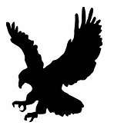

Table of Contents

Declaration 3

Preparing 3

Installation 3

1. Hardware connection 3

2. Software configuration 4

3. Configuration 4

Wiring Diagram 5

Stepper Motor Connection 6

# Declaration

Thank you for choosing the Mach3 breakout control card (controller board). Before using this card, please read the following statement and terms:

1. The original manual is provided by the manufacturer in a non-English version. Our team has translated it into English. We have tested the basic functionality of the card but were unable to perform full functional testing.
2. The driver that comes with the card is also provided by the manufacturer. All copyrights are owned by the manufacturer. We did not make any modifications to it, nor are we able to test it on all computer operating systems.
3. Any software required to use this card should be prepared and installed by the user. This user manual only includes information directly related to the card and does not provide detailed technical tutorials for the software (e.g., Mach3, G-code, etc.).
4. Using this card requires connecting an additional power source, whether it's low-voltage DC or AC. Users must pay attention to safety and bear all associated risks.
5. Using this card may cause damage to your equipment or processing process, and users are responsible for bearing such risks.

# Preparing

1. Computer with USB interface. (This card has an auto-detected USB port, so no special USB driver is needed.)
2. Pre-installed Mach3 software (Reference: <https://www.machsupport.com/>)
3. OS with Mach3 installed. (This card has been tested on XP, Win7, Win8, and Win10 (32-bit, some builds of 64-bit).)
4. Necessary hardware, for example: Power supply, stepper motors with drives, emergency stop, limit switches, and inverter, etc.

# Installation

## Hardware connection

* + Connect the controller board with computer with USB cable. The blue light will be turned on if the card is properly detected; Connect the controller only, do not connect DC, Stepper motor driver and all other devices during the configuration, the USB power is enough to configure the controller board.
  + There are two terminal blocks on the board, and they are physically isolated. During wiring, please ensure that there is no connection between the two groups of signal wires on these two rows of terminals. Otherwise, external interference signals may enter the control circuit of the control board and the motherboard of the microcomputer, leading to a reduction in the system's anti-interference ability. Below figure 1 is a bad sample that wired by using the shared ground pins from two terminal bocks.

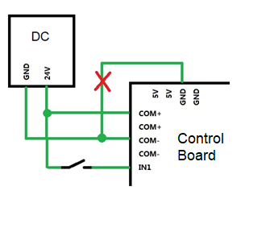

Figure 1

## Software configuration

* + (Option) A pre-configured Mach3 configuration file, **Mach3Mill.xml**, covers most common Mach3 configurations for beginners. This file can be copied to the Mach3 installation folder to save time. **Caution:** This is a reference file only and may not be properly configured for all machines.
  + Copy the driver file (RnRMotion.dll) into the Mach3 installation folder\Plugins

## Configuration

* + Start Mach3Mill. In the device selection window, select ‘RnRMotionControllerECO-V2.0’

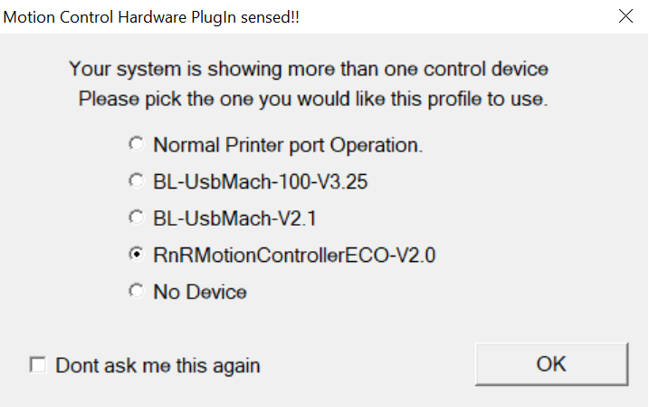

Figure 2

* + In the Main Menu -> Plugin Control, the ‘RnR Motion’ should be appeared, and select it. The following dialog should be displayed, see Figure 3.

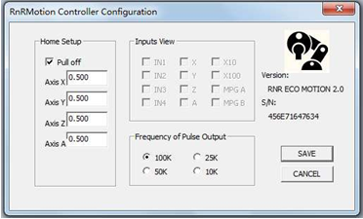

Figure 3

In some cases, this Controller window may not appear. This indicates that either the driver is not compatible with the OS, or the driver is not compatible with the Mach3 version, or the Windows system has conflicting software installed. **Tips:** Since Mach3 is relatively old software, it may not be fully compatible with the latest Windows 10 64-bit systems. Try a freshly installed version of Windows 10 or a previous version of Windows to resolve this issue.

# Wiring Diagram

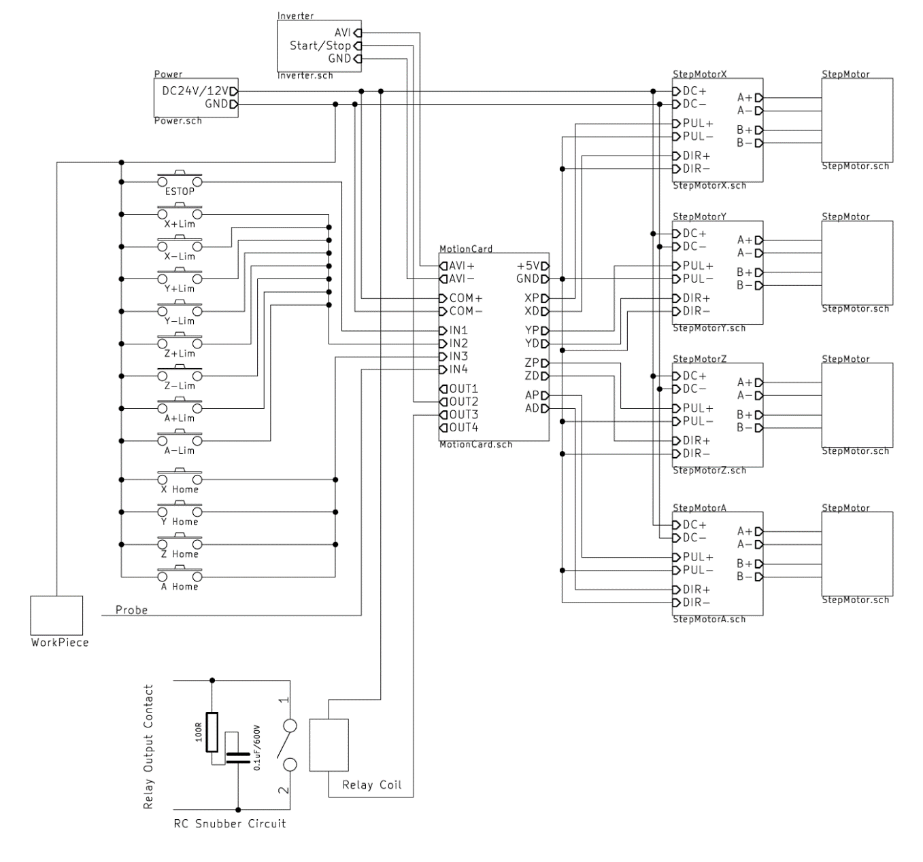

## Stepper Motor Connection

The most important part of hardware wiring is to connect the control card to the motor drive module. The connection to the motor drive module can be done in two ways: common cathode connection and common anode connection. Among them, the common cathode connection, table below is sample for X-axis:

|  |  |  |
| --- | --- | --- |
| Connection Type | Controller Terminal | Stepper Motor Driver |
| Common Cathode | XP | PUL+ |
| GND | PUL- |
| XD | DIR+ |
| GND | DIR- |
| Common Anode | XP | PUL- |
| 5V | PUL+ |
| XD | DIR- |
| 5V | DIR+ |

The common anode connection can provide a higher current output. However, the common anode connection requires modifying the level configuration in Mach3; otherwise, the motor will not rotate properly.